Prompt 1: Initial Code Generation Prompt:
Write a beginner-friendly C++ console program that generates random student excuses. The program should ask the user to enter their name.
Store at least 10 excuse templates using a {name} placeholder. Randomly select one excuse each time the program runs.
Replace {name} with the actual user input.
Handle empty input properly and display an error message. Add comments in the code so beginners can understand it.

Code
#include <iostream> #include <vector>
#include <cstdlib> #include <ctime>
using namespace std;

// BUG: replaces only first occurrence
string personalize(string text, string name) { size_t pos = text.find("{name}");
if (pos != string::npos) {
text.replace(pos, 6, name);
}
return text;
}

int main() {
string name;
cout << "Enter your name: "; getline(cin, name);
if (name.empty()) {
cout << "Error: Name cannot be empty!" << endl; return 0;
}

vector<string> excuses = {
"{name} couldn’t finish because {name}'s laptop crashed.", "{name} tried submitting but {name}'s file disappeared.", "{name}'s system froze while working.",
"{name} forgot to save the file.",
"{name}'s internet stopped working.", "{name} accidentally deleted the file.", "{name}'s computer restarted suddenly.", "{name} faced a power cut.",
"{name} got logged out suddenly.", "{name}'s keyboard stopped working."
};

srand(time(0));
int index = rand() % excuses.size();

cout << personalize(excuses[index], name) << endl; return 0;
}

Ouput
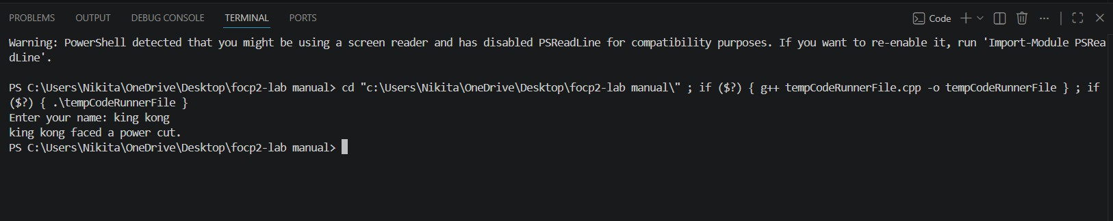
Prompt2:
Improve the previous program.
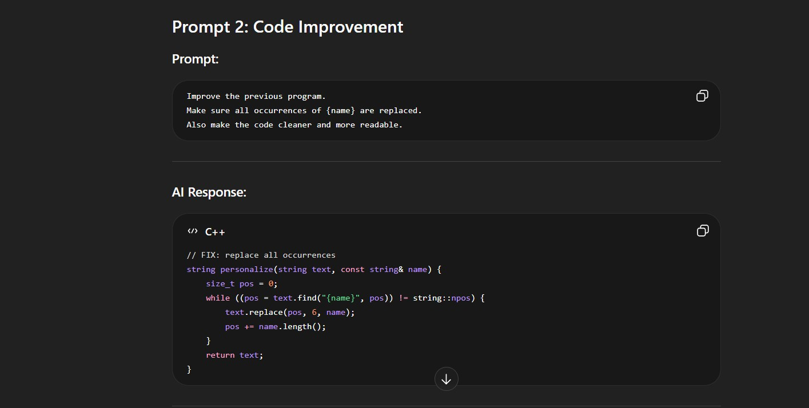
Make sure all occurrences of {name} are replaced. Also make the code cleaner and more readable.

Code
#include <iostream> #include <vector>
#include <cstdlib> #include <ctime>
using namespace std;

// Improved function: replaces ALL occurrences of {name} string personalize(string text, const string& name) {
size_t pos = 0;

// Loop to replace every occurrence
while ((pos = text.find("{name}", pos)) != string::npos) { text.replace(pos, 6, name);
pos += name.length(); // Move forward after replacement
}
return text;
}

int main() {
string name;

// Take input from user
cout << "Enter your name: "; getline(cin, name);

// Handle empty input if (name.empty()) {
cout << "Error: Name cannot be empty!" << endl; return 0;
}

// Excuse templates (with multiple {name}) vector<string> excuses = {
"{name} couldn’t finish because {name}'s laptop crashed.", "{name} tried submitting but {name}'s file disappeared.", "{name}'s system froze while {name} was working.",
"{name} forgot to save the file.",
"{name}'s internet stopped working when {name} was uploading.", "{name} accidentally deleted the file.",
"{name}'s computer restarted suddenly.", "{name} faced a sudden power cut.",
"{name} got logged out while {name} was submitting.", "{name}'s keyboard stopped working during typing."
};

// Initialize random seed
srand(time(0));

// Select random excuse
int index = rand() % excuses.size();

// Personalize excuse
string finalExcuse = personalize(excuses[index], name);

// Display output
cout << finalExcuse << endl;

return 0;
}
Ouput

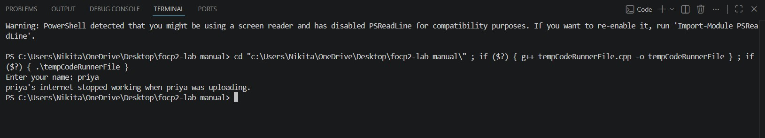

Prompt 3: Bug Identification Prompt:
My program is not replacing {name} correctly in all cases. Sometimes only one occurrence is replaced.
Why is this happening?
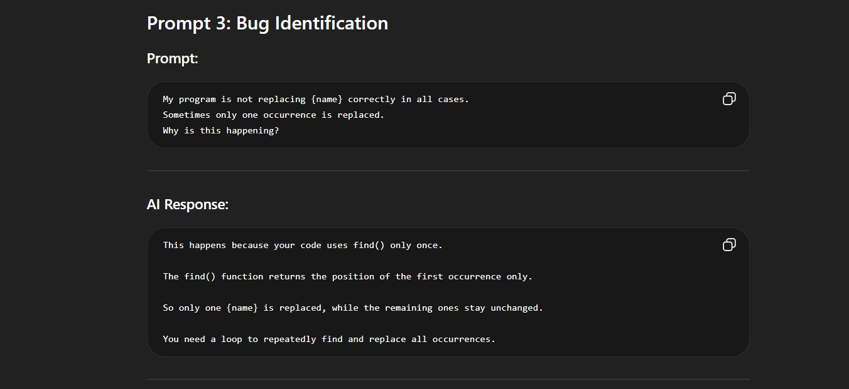

Prompt 4: Bug Fix Request Prompt:
Fix the issue so that all occurrences of {name} are replaced correctly. Explain the fix simply.
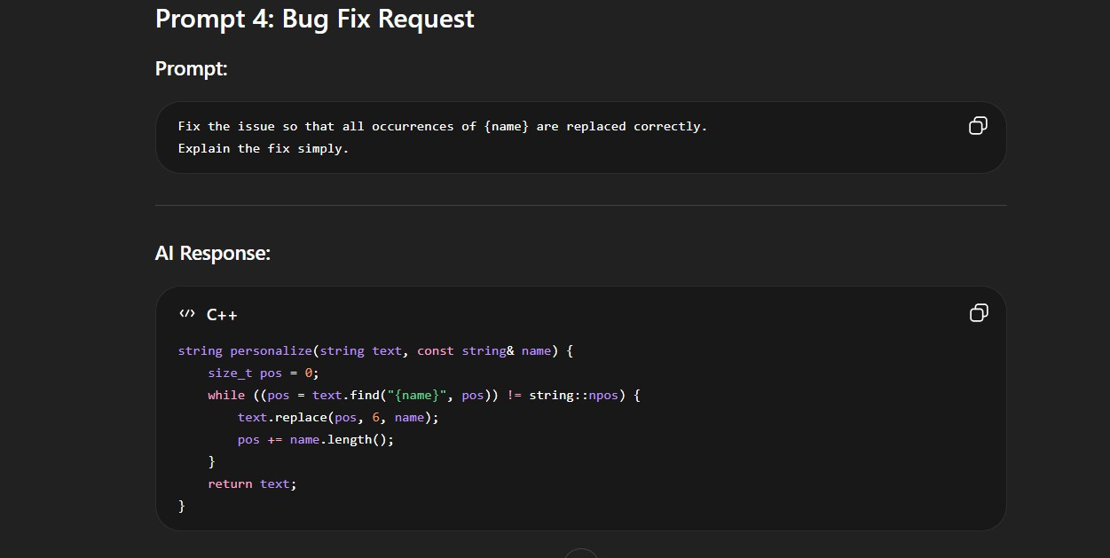
Code
#include <iostream> #include <vector>
#include <cstdlib> #include <ctime>
using namespace std;

// FIXED FUNCTION (from Prompt 4)
string personalize(string text, const string& name) { size_t pos = 0;

// Replace ALL occurrences of {name}
while ((pos = text.find("{name}", pos)) != string::npos) { text.replace(pos, 6, name);
pos += name.length();
}

return text;
}

int main() {

// Take user input
cout << "Enter your name: "; getline(cin, name);

// Handle empty input if (name.empty()) {
cout << "Error: Name cannot be empty!" << endl; return 0;
}

// Excuse templates
vector<string> excuses = {
"{name} couldn’t finish because {name}'s laptop crashed.", "{name} tried submitting but {name}'s file disappeared.", "{name}'s system froze while {name} was working.",
"{name} forgot to save the file.",
"{name}'s internet stopped working when {name} was uploading.", "{name} accidentally deleted the file.",
"{name}'s computer restarted suddenly.", "{name} faced a sudden power cut.",
"{name} got logged out while {name} was submitting.", "{name}'s keyboard stopped working during typing."
};

// Initialize random generator srand(time(0));

// Select random excuse
int index = rand() % excuses.size();
// Apply fix (replace all {name})
string finalExcuse = personalize(excuses[index], name);

// Output result
cout << finalExcuse << endl;

return 0;
}
Output

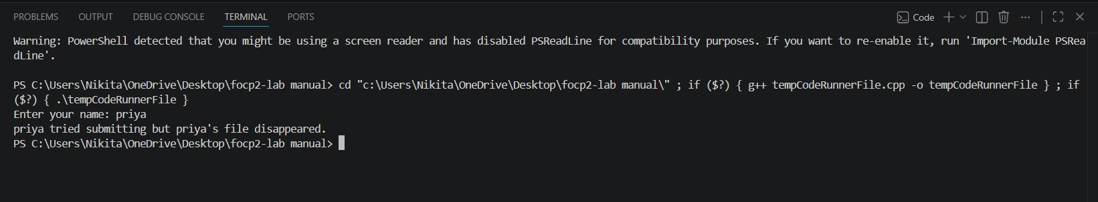
FINAL CODE
#include <iostream> #include <vector>
#include <cstdlib> #include <ctime>
using namespace std;

string personalize(string text, const string& name) { size_t pos = 0;
while ((pos = text.find("{name}", pos)) != string::npos) { text.replace(pos, 6, name);
pos += name.length();
}
return text;
}

int main() {
cout << "Enter your name: "; getline(cin, name);

if (name.empty()) {
cout << "Error: Name cannot be empty!" << endl; return 0;
}

vector<string> excuses = {
"{name} couldn’t finish because {name}'s laptop crashed.", "{name} tried submitting but {name}'s file disappeared.", "{name}'s system froze while working.",
"{name} forgot to save the file.",
"{name}'s internet stopped working.", "{name} accidentally deleted the file.", "{name}'s computer restarted suddenly.", "{name} faced a power cut.",
"{name} got logged out suddenly.", "{name}'s keyboard stopped working."
};

srand(time(0));
int index = rand() % excuses.size();

cout << personalize(excuses[index], name) << endl; return 0;
} OUTPUT
